Phishing Challenge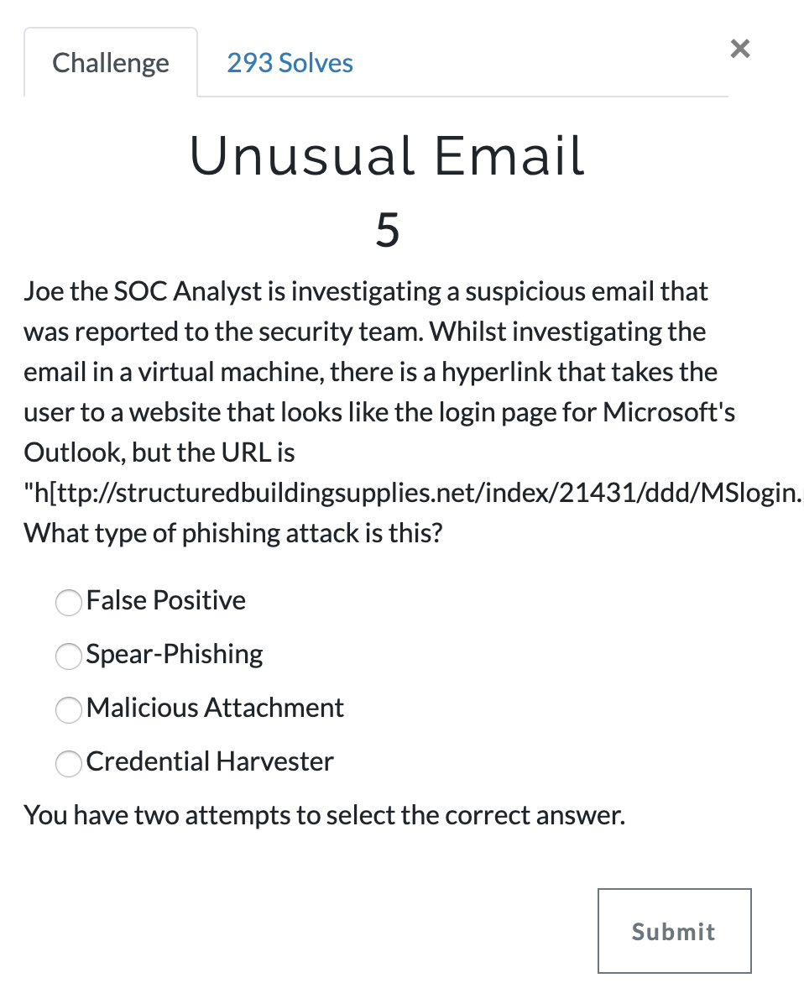
Answer: Credential Harvester

